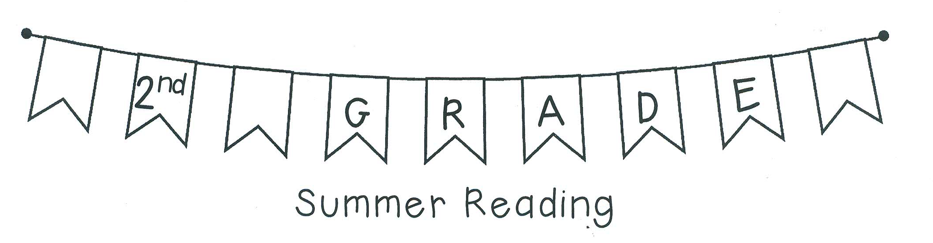Dear Parents and Families,
Over the summer, I'd like for your child to read as much as they can! Aim to read 10-15 minutes most days. The Book List on the back is a great starting place to find books that your student (and you!) can enjoy. The Book List is a guide, so if the books are too easy or too hard please help your student select books that are appropriate for their reading level. Record all of your reading on the Reading Log.
Please help your student to choose one of the books from the Book List to complete the Postcard assignment. Bring the assignment and your Reading Log on the first day of school.
Have a great summer!
Mrs. Michelle Parkinson

